CVMA REGION X RALLY
RIDE PLAN
Saturday, August 22, 2026 | KSU 1000
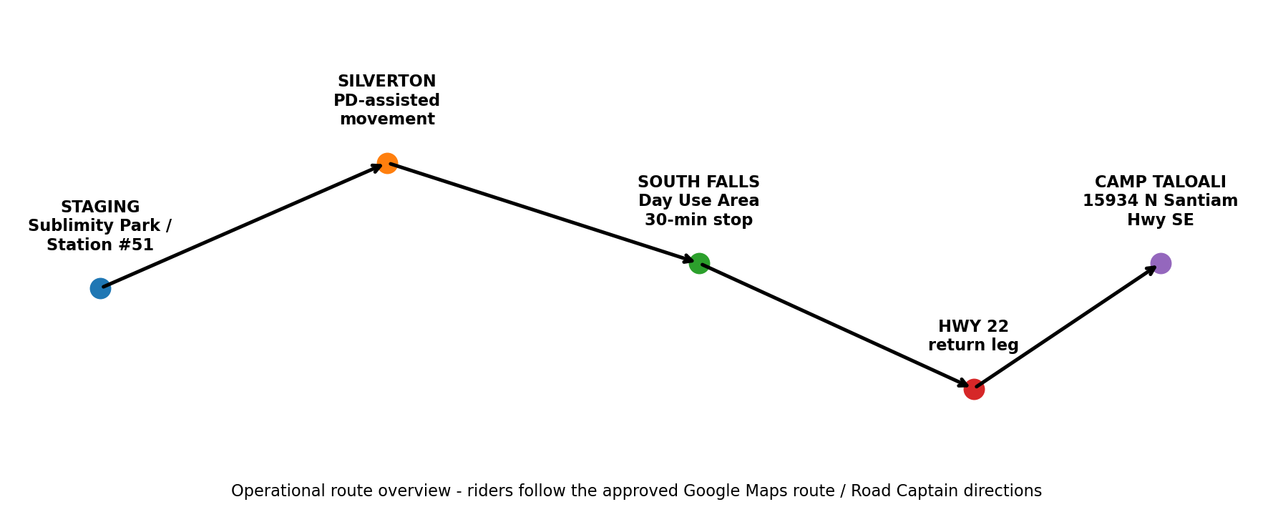
Route: Sublimity staging → Silverton → Silver Falls State Park, South Falls → Hwy 22 → Camp Taloali

1. Timeline
Time | Action
0930 NLT | All riders and support personnel staged
0940 | Safety brief - grassy area at Sublimity Park
0950 | Mount / final equipment and formation check
1000 | KSU - Advance Party departs; Main Body follows approximately 10 seconds later
~1045 | Planned arrival - South Falls Day Use Area*
1045-1115 | 30-minute waterfall / restroom break
1120 NLT | All riders back at motorcycles (10 minutes before planned KSU)
1130 | Planned KSU - depart South Falls*
~1230 | Planned arrival - Camp Taloali*
*Planning times are estimates and should be adjusted by the Road Captain for traffic, group size, weather, and law-enforcement coordination.

2. Ride Organization
Advance Party: Road Captain + ten (10) CVMA 29-4 blockers. Stage on NW Starr St next to Sublimity Park, between NW Johnson St and NW Parker St.
Main Body: CVMA 29-4 President at the front, followed by all riders. Stage on NW Johnson and NW Starr St. All riders will fall behind on NW Johnson, W Main St and NW Parker St. Overflow will stage at Fire Station parking lot and in the gravel parking area adjacent to Sublimity Fire District Station #51, with additional parking at the post office as needed.
Rear Security: CVMA 29-4 Sergeant-at-Arms (SA) + two (2) CVMA 29-4 members. Stage on the east side of the post-office parking area.

3. Start / Sublimity
- Safety brief will be conducted in the grassy area of Sublimity Park.
- Before movement, the SA and two rear-security members will position as assigned at NW Starr St / NW Center St. Block North and South bounds traffic on N Center, and west bound traffic of NE Starr St.
- Advance Party leads. Main Body departs approximately 10 seconds later. Rear Security follows the final rider.
- Advance Party will move ahead to pre-identified observation/control points and intersections. Blockers may/will leave their control point when main body is in view and approaches the control pint. Blockers will only leave their post if it is safe to do so, and rejoin the advance party.

4. Silverton Police Coordination
Link-up point: W Main St / Westfield St area, near The Church of Jesus Christ of Latter-day Saints, 745 W Main St, Silverton.
- Silverton PD will provide a rolling escort through Silverton.
- Planned movement: eastbound W Main St → southbound S Water St → Quall Rd NE / Canyon View Ln NE. Silverton PD will take control of the intersection until the last riders clears the intersection of Quall RD NE / Canyon View NE.
- Maximum formation speed through Silverton: 25 MPH or the posted limit, whichever is lower.
- Silverton PD remains in control of police traffic-control points. Riders and CVMA support personnel will comply with all officer directions.
- After the formation clears the police-assisted section, the Advance Party continues toward Silver Falls and prepares the next planned ride-management points. Main body to maintain a distance of 10 seconds behind the advance party.

5. Silver Falls State Park - South Falls
- Use the South Falls Day Use Area / main parking area. Overflow parking may be used if directed by park staff or the Road Captain.
- Break duration: 30 minutes for waterfall viewing and restroom use.
- All riders will return to their motorcycles NLT 10 minutes before KSU.
- Advance Party regroups in the easternmost practical parking stalls; Main Body stages behind the Advance Party; Rear Security takes the rear.
- Main Body departs approximately 10 seconds after the Advance Party.

6. Return to Camp Taloali
- Advance Party leads the return leg from South Falls toward Hwy 22 and Camp Taloali using the approved route.
- Advance Party personnel may position at pre-identified points only when it can be done safely and lawfully; they do not supersede traffic-control devices or law-enforcement direction.
- Main Body maintains formation, safe following distance, and lane discipline.
- Rear Security remains behind the final rider and reports breakdowns, separation, or hazards to the Road Captain.
- Final destination: Camp Taloali, 15934 N Santiam Hwy SE, Stayton, OR 97383.

7. Rider Safety Brief - Key Points
- Ride your own ride. Each rider is responsible for the safe and lawful operation of their motorcycle.
- Obey all traffic-control devices and law-enforcement directions. Do not enter an intersection unless it is safe.
- Maintain formation without sacrificing safe following distance. No racing to close gaps.
- No formation speed above the posted limit; Silverton formation speed will not exceed 25 MPH.
- Use clear hand signals and pass signals rearward when safe.
- If separated from the group, continue safely on the route; do not make unsafe maneuvers to catch up.
- Emergency vehicles always have priority. Yield immediately and safely.
- Report mechanical issues or rider problems to Rear Security / Road Captain as soon as practical.
- At Silver Falls, stay within open public areas and obey all park closures, barriers, and staff directions.

8. Command / Communications (Primary Comms cell phone)
Element | Lead | Primary Responsibility
Advance Party | Road Captain “Mika” 971-409-6368” | Route lead, coordination, hazards, authorized ride-management points
Main Body | 29-4 President “Leafty” 417-576-7756 | Main formation
Rear Security | 29-4 Sergeant-at-Arms “Snuggles” 503-851-4751 | Rear accountability, breakdowns, stragglers, hazards

9. Pre-Ride Coordination Checklist
☐ Confirm final Google Maps route and distribute to Advance Party / Rear Security.
☐ Confirm Silverton PD link-up time, contact person, exact start/end of police traffic-control assistance.
☐ Confirm South Falls parking plan.
☐ Confirm blocker assignments and legal/safety limits for each planned point.
☐ Check weather, road construction, closures, and wildfire restrictions on August 22.
☐ Confirm rider count and emergency contact / sweep procedure.
☐ Conduct communications check before 0940 safety brief.
Prepared for CVMA Region X Rally - Ride Date: 22 AUG 2026

